Apply filters to SQL queries

Project description
In this project, I use SQL to investigate potential security issues involving employee login attempts and employee machines. By querying and filtering data from the employees and log_in_attempts tables, I aim to identify suspicious login patterns such as repeated failed attempts, logins outside of standard business hours, and access from unauthorized locations.
Through data analysis, I seek to correlate login behavior with specific employees and machines to detect possible compromised accounts or policy violations.

Retrieve after hours failed login attempts
In this query, I selected all the columns with the line “SELECT *”, from the log in attempts table with the line “FROM log_in_attempts”. I used then “WHERE login_time > ‘18:00’ AND success = 0” to see all the failed login attempts after the working hours.
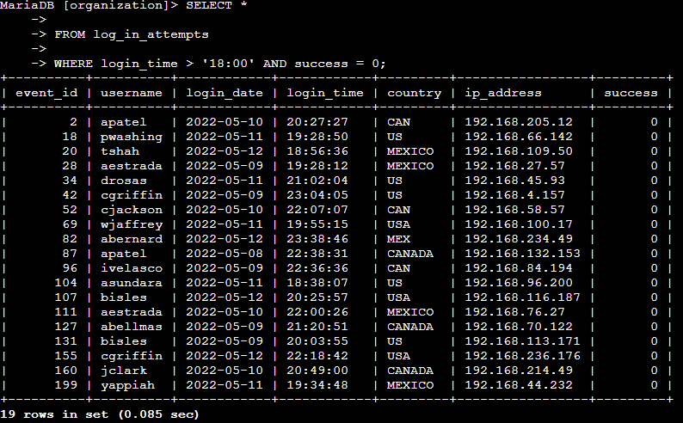

Retrieve login attempts on specific dates
I selected here all the columns from log_in_attempts that have an entry with the dates 2022-05-09 or 2022-05-08.
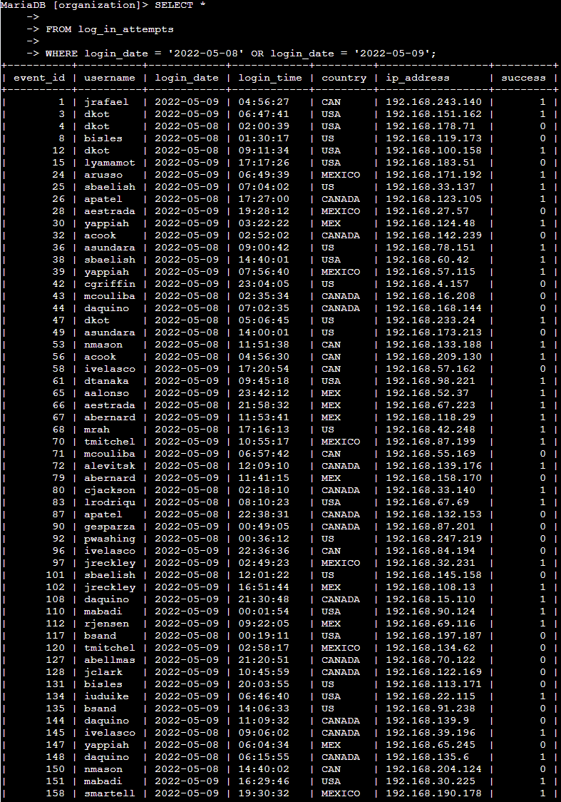

Retrieve login attempts outside of Mexico
I selected here all the columns from log_in_attempts that do not have an entry with the country being Mexico. I used “MEX” to filter because some entries have MEX or MEXICO.
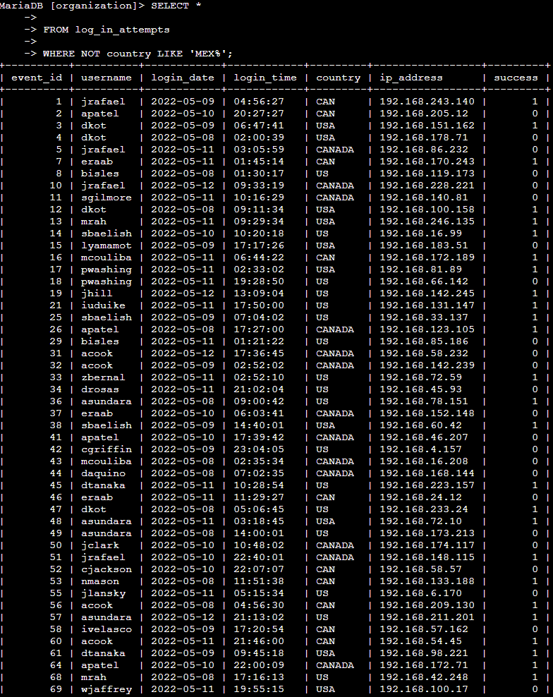

Retrieve employees in Marketing
I selected here all the columns from log_in_attempts that have an entry for the department set to Marketing, and also that have their offices at the East Building. Because all the offices have names like East followed by a number, I used “East” to filter them.

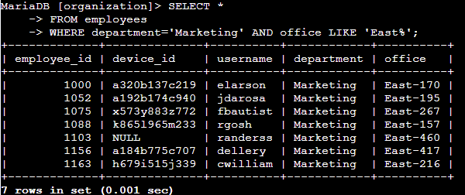

Retrieve employees in Finance or Sales
I selected here all the columns from log_in_attempts that have an entry for the department set to Finance or Sales.
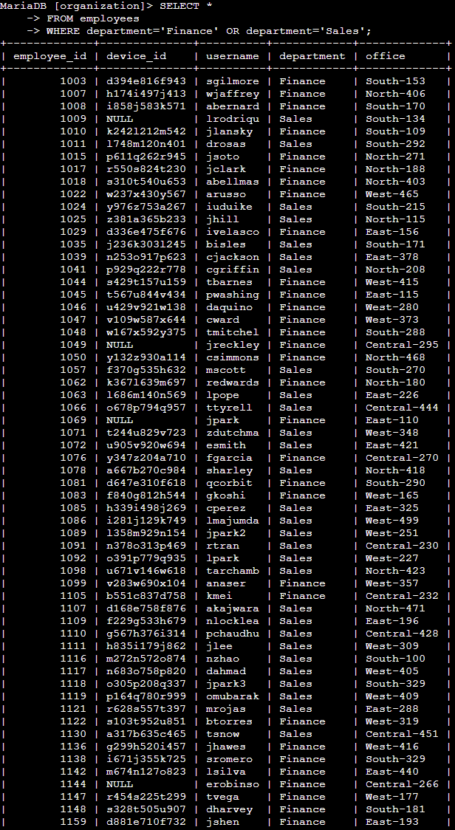

Retrieve all employees not in IT
I selected here all the columns from log_in_attempts that do not have an entry for the department set to Information Technology.
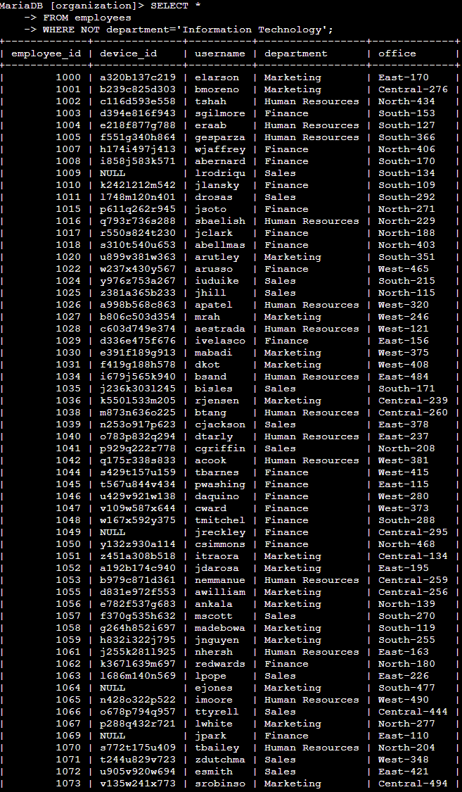

Summary
In this project, I applied SQL filters to analyze employee and login data in order to identify potential security risks. By retrieving and narrowing down specific records, I was able to detect suspicious login activity and evaluate employee access patterns to support security monitoring efforts.

